Name: G MADHAVA REDDY
Reg No: 192312436
Course Code: CSA1718
Experiment 1
Map Colouring using Constraint Satisfaction Problem (CSP)
Aim
To write a Python program for solving the Map Colouring problem using the Constraint Satisfaction Problem (CSP) approach.
Objective
- To understand CSP concepts.
- To assign different colours to adjacent regions.
- To ensure no neighbouring regions have the same colour.

Algorithm
- Define the map as a graph.
- Assign available colours.
- Select an uncoloured region.
- Check if assigning a colour violates any constraints.
- If safe, assign the colour.
- Repeat recursively for all regions.
- If no colour is possible, backtrack.
- Display the valid colouring.

Flowchart
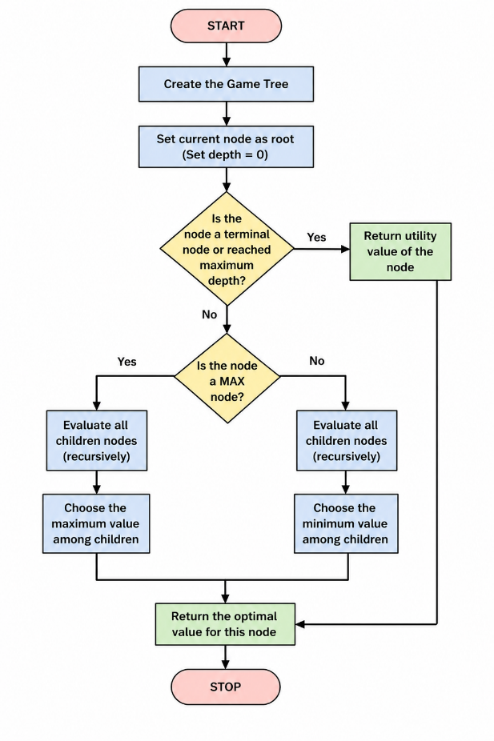

Code
graph = {
'A': ['B', 'C'],
'B': ['A', 'C', 'D'],
'C': ['A', 'B', 'D'],
'D': ['B', 'C']
}

colors = ['Red', 'Green', 'Blue']
result = {}

def is_safe(node, color):
for neighbor in graph[node]:
if result.get(neighbor) == color:
return False
return True

def solve(nodes, index):
if index == len(nodes):
return True

node = nodes[index]

for color in colors:
if is safe(node, color):
result[node] = color

if solve(nodes, index + 1):
return True

result[node] = None

return False

nodes = list(graph.keys())

solve(nodes, 0)

print("Map Coloring Solution:")
for node in nodes:
print(node, ":", result[node])

Output
Map colouring Solution:
A : Red
B : Green
C : Blue
D : Red

Result
The map was successfully coloured using the CSP backtracking algorithm without violating adjacency constraints.

Conclusion
The Map Colouring problem was solved successfully using Constraint Satisfaction and Backtracking.

Experiment 2
Tic Tac Toe Game
Aim
To write a Python program for implementing the Tic Tac Toe game.
Objective
- To understand game implementation.
- To allow two players to play alternately.
- To detect winner or draw.
Algorithm
- Create a 3×3 board.
- Display the board.
- Take player input.
- Place player's symbol.
- Check rows, columns, and diagonals.
- If winner exists, end game.
- If board is full, declare draw.
- Otherwise continue.
Flowchart
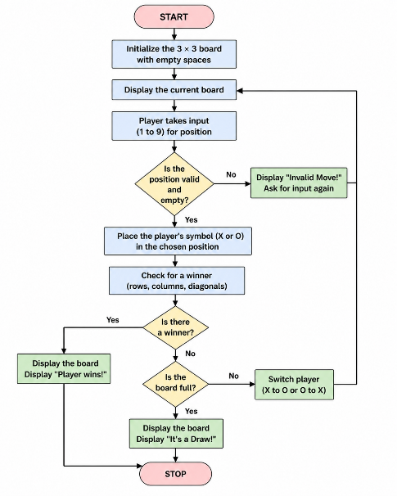
Code
board = [' ' for _ in range(9)]

def print_board():
print(board[0], '|', board[1], '|', board[2])
print('--+---+--')
print(board[3], '|', board[4], '|', board[5])
print('--+---+--')
print(board[6], '|', board[7], '|', board[8])

def winner(player):
wins = [
[0,1,2],[3,4,5],[6,7,8],
[0,3,6],[1,4,7],[2,5,8],
[0,4,8],[2,4,6]
]
for w in wins:
if all(board[i]==player for i in w):
return True
return False

player='X'

for turn in range(9):
print_board()
pos=int(input("Enter position (1-9): "))-1

if board[pos]==' ':
board[pos]=player

if winner(player):
print_board()
print(player,"Wins!")
break
player='O' if player=='X' else 'X'
else:
print("Invalid Move")
else:
print_board()
print("Draw")

Output
X | O | X
--+---+--
O | X | O
--+---+--
O | X | X

X Wins!

Result
The Tic Tac Toe game was implemented successfully and correctly identified the winner or draw.

Conclusion
The game logic worked correctly by allowing alternate moves and detecting winning conditions.
Experiment 3
Minimax Algorithm for Gaming
Aim
To write a Python program implementing the Minimax Algorithm for game decision making.
Objective
- To understand adversarial search.
- To implement Minimax recursion.
- To determine the optimal move.

Algorithm
- Create the game tree.
- If terminal node, return utility value.
- If MAX node, choose maximum value.
- If MIN node, choose minimum value.
- Continue recursively.
- Return optimal utility.

Flowchart
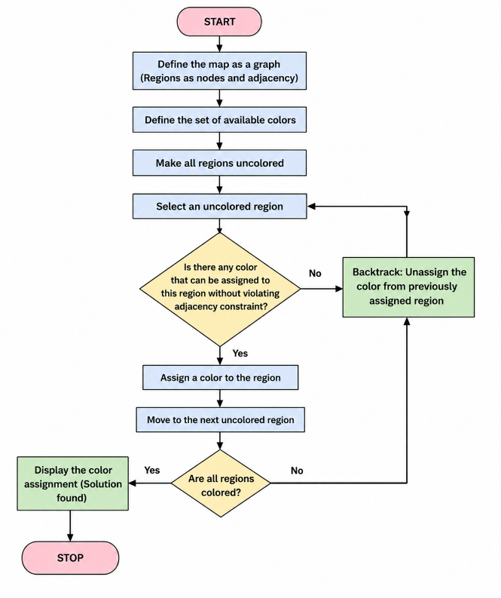
Code
import math

def minimax(depth, node, maximizing, values, height):
if depth == height:
return values[node]

if maximizing:
return max(
minimax(depth+1, node*2, False, values, height),
minimax(depth+1, node*2+1, False, values, height)
)
else:
return min(
minimax(depth+1, node*2, True, values, height),
minimax(depth+1, node*2+1, True, values, height)
)

values = [3,5,6,9,1,2,0,-1]

height = int(math.log2(len(values)))

print("Optimal Value:", minimax(0,0,True,values,height))

Output
Optimal Value: 5

Result
The Minimax algorithm successfully evaluated the game tree and selected the optimal utility value.

Conclusion
The Minimax algorithm effectively determines the best possible move by recursively maximizing and minimizing utility values in a game tree.

